Competitive Shooters of Lake Norman USPSA February 13th, 2026
COURSE DESIGNER: Ryan Christenson

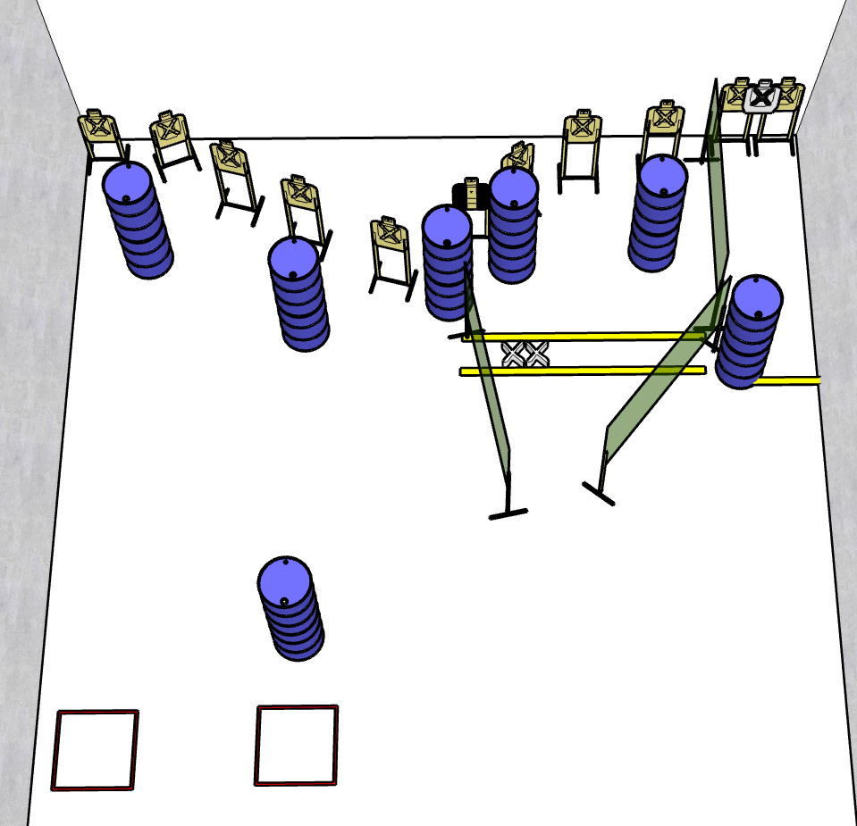

Stage 2 – I’m bananas for you
22 rounds, 110 points, Comstock
There are 11 cardboard targets with some no-shoots.
Start position is both Feet on XXs
Handgun is loaded holstered with wrists below belt.
PCC is loaded and held with both hands and stock touching belt.
On the audible start signal, engage targets from within the shooting area.
Stage 4 – I’m stuck on you like glue
24 rounds, 120 points, Comstock
There are 12 cardboard targets with some no-shoots.
Start position anywhere inside the shooting area
Handgun is unloaded and holstered with wrists above ears.
PCC is unloaded with wrists above ears.
On the audible start signal, engage targets from within the shooting area.

